Programm

e

: MCA

Semeste

r

: Fall 2019

Course :

Database

Technologies(Embedded Lab)

Code : ITA5008

Faculty :

Prof. Jayanthi &

Prof. M. Premalatha

Slot : L23 + L24

Ex. No. 3

Date: 1/8/19

SQL - Integrity Constraints

Create the following tables and apply constraints as follows

1. Books Table:

a. isbn – primary key

b. title

c. price

d. qty – not null

2. Authors Table:

a. authorId – primary key

b. email - unique

3. Book_Authors:

a. isbn – foreign key references books table

b. authorId – foreign key references authors table

Programm

e

: MCA

Semeste

r

: Fall 2019

Course :

Database

Technologies(Embedded Lab)

Code : ITA5008

Faculty :

Prof. Jayanthi &

Prof. M. Premalatha

Slot : L23 + L24

Ex. No. 3

Date: 1/8/19

SQL - Integrity Constraints

Create the following tables and apply constraints as follows

1. Books Table:

a. isbn – primary key

b. title

c. price

d. qty – not null

2. Authors Table:

a. authorId – primary key

b. email - unique

3. Book_Authors:

a. isbn – foreign key references books table

b. authorId – foreign key references authors table

Integrity Constraints

1. Create the following tables and apply constraints as follows
2. Books Table

a. isbn – primary key

b. title

c. price

d. qty – not null

2. Authors Table :

a. authorId – primary key

b. email – unique

3. Book_Authors:

a. isbn – foreign key references books table

b. authorId – foreign key references authors table

Write SQL Queries for the following:

Constraints:

Write SQL Queries for the following:

Constraints:

Write SQL Queries for the following:Constraints:

1. Add unique constraint to title in books table

2. Add not null constraint to price in books table

3. Alter not null constraint in price attribute in books

table and set the check constraint so that value is

greater than 0.0

4. Drop not null constraint for qty in books table

5. Set a default value of qty in books table as 0

6. Drop unique constraint for email attribute in authors

table

7. Drop any one foreign key constraint.

8. Drop a primary key [after referenced foreign key is

dropped]

9. Add an attribute for authors table and set a constraint

for it.

1. Add unique constraint to title in books table

2. Add not null constraint to price in books table

3. Alter not null constraint in price attribute in bookstable and set the check constraint so that value isgreater than 0.0

4. Drop not null constraint for qty in books table

5. Set a default value of qty in books table as 0

6. Drop unique constraint for email attribute in authors table

7. Drop any one foreign key constraint.

8. Drop a primary key [after referenced foreign key is dropped]

9. Add an attribute for authors table and set a constraint for it.

1. HR Database Diagram

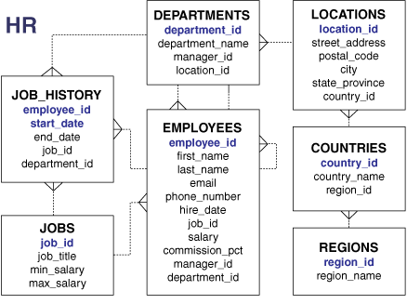

1. Create a query to display all the data from the *Employees* table.
2. Create a query to display the unique manager numbers from *Employees* table.
3. Create a query to display the unique salaries in *Employees* tables.
4. Create a query to display the unique combination of values in *department_id* and *job_id* columns

Programm

e

: MCA

Semeste

r

: Fall 2019

Course :

Database

Technologies(Embedded Lab)

Code : ITA5008

Faculty :

Prof. Jayanthi &

Prof. M. Premalatha

Slot : L23 + L24

Ex. No. 3

Date: 1/8/19

SQL - Integrity Constraints

Create the following tables and apply constraints as follows

1. Books Table:

a. isbn – primary key

b. title

c. price

d. qty – not null

2. Authors Table:

a. authorId – primary key

b. email - unique

3. Book_Authors:

a. isbn – foreign key references books table

b. authorId – foreign key references authors table

Programm

e

: MCA

Semeste

r

: Fall 2019

Course :

Database

Technologies(Embedded Lab)

Code : ITA5008

Faculty :

Prof. Jayanthi &

Prof. M. Premalatha

Slot : L23 + L24

Ex. No. 3

Date: 1/8/19

SQL - Integrity Constraints

Create the following tables and apply constraints as follows

1. Books Table:

a. isbn – primary key

b. title

c. price

d. qty – not null

2. Authors Table:

a. authorId – primary key

b. email - unique

3. Book_Authors:

a. isbn – foreign key references books table

b. authorId – foreign key references authors table